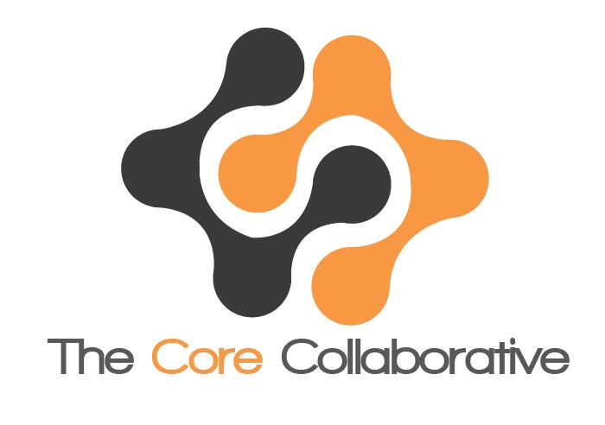
The Core Collaborative, Inc.
4629 Cass Street #292, San Diego, CA 92109

VISUAL AUDIO LIKENESS RELEASE - ADULT

For good and valuable consideration, the receipt and sufficiency of which is acknowledged, I hereby authorize The Core Collaborative, Inc. and its employees, representatives, affiliates, licensees, assignees, and authorized agents to photograph and record me in video or audio format, and to use, exploit, adapt, modify, reproduce, distribute, publicly display in any form now known or later developed, my image or my visual likeness, name and/or voice, by incorporating it or them into publications, catalogues, brochures, books, magazines, photo exhibits, internet websites, videotapes and/or other media for educational, informational, commercial or promotional materials related thereto.

I am aware that I will not receive monetary compensation for my participation. I further understand and agree that The Core Collaborative, Inc. is the exclusive owner of all rights, title and interest, including copyright, in such photographs, videotapes and/or other audio-visual electronic materials.

I release The Core Collaborative, Inc. and its employees, representatives, affiliates, licensees, assignees, and authorized agents, from all claims that may arise from the use of the above-mentioned materials including, without limitation, all claims of rights of publicity, invasion of privacy, defamation, infringement of moral rights, or copyright infringement.

I am over the age of 18, have the right to contract in my own name, and have read this Visual Audio Likeness Release – Adult form. I fully understand and agree with its terms and conditions.

Name (please print):

Signature:

Date:

Address:

Tel. number:

E-mail:

